HOUSE  RECOVERY  Come and meet Canterbury’s drug and alcohol treatment providers under one roof.  Date: FriDAY 12th October  TIME: 1pm – 3pm  CHRISTCHURCH CENTRAL SERVICE EXPO  An expo showcasing the services that are offered in the community for consumers with alcohol and other drug issues, their families and concerned others.  Find out what’s available in the Alcohol and Drug treatment sector: - Education and self-help groups, Support for Youth through to the over 65’s, Treatment provider options, Peer Support, Day and residential programmes, Gambling support etc  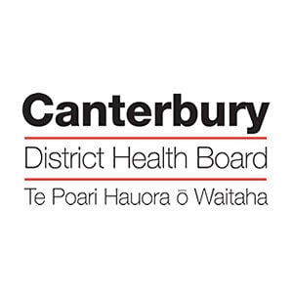 | CHRISTCHURCH CENTRAL SERVICE EXPO  ────  A TASTER OF GROUPS OFFERED  ────  INTERACTIVE DISPLAYS  INFORMATION SHARING  ────  REFRESHMENTS PROVIDED  cHRISTCHURCH CENTRAL SERVICE  55-59 fERRY rOAD  Level 1  PHONE 033384437  www.odysseychch.org.nz

