Arowhenua Whanau Services
Providing a wide range of integrated services to all Mᾱori and non-Mᾱori living within the Aoraki rohe

Mental Health Awareness Week
“Nature is the Key”
11 October 2017, 10.30 – 1pm
Awarua Wetlands Planting Day
Huirapa St, Temuka
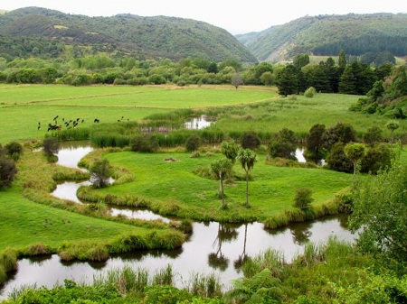
BBQ lunch provided
Bring gumboots, gloves and a spade
92A King Street, Temuka
Phone: 03 615 5180
Email: admin@aws.health.nz
www.aws.health.nz

