**MENTAL HEALTH AWARENESS WEEK**

**9-15 October**

COME TO THE OT ROOM FOR A SENSATIONAL EXPERIENCE…

[](http://www.google.co.nz/url?sa=i&rct=j&q=&esrc=s&source=images&cd=&cad=rja&uact=8&ved=0ahUKEwjar-nX1tDWAhWIEbwKHWoHCqQQjRwIBw&url=http://www.bpfp.net/?tribe_events%3Dwhat-you-dont-know-about-lavender&psig=AOvVaw3oXrciHprrhQtloltbUpwQ&ust=1506990345934519)[](http://www.google.co.nz/url?sa=i&rct=j&q=&esrc=s&source=images&cd=&cad=rja&uact=8&ved=0ahUKEwiottHS1NDWAhUMi7wKHU9UArgQjRwIBw&url=http://www.sensorycorner.co.nz/catalog/index.php?main_page%3Dproduct_info%26products_id%3D512&psig=AOvVaw339M-Vthm3Ty_j1uzl4tBo&ust=1506989792920189)

[](https://www.google.co.nz/imgres?imgurl=http://theweightedblanketco.com/img/Red.jpg&imgrefurl=http://theweightedblanketco.com/&docid=YoDMPQiTmLY_mM&tbnid=m4O67Ymh7WxEoM:&vet=10ahUKEwi5qf691NDWAhWDXbwKHVO3BzwQMwjXAShIMEg..i&w=300&h=174&bih=908&biw=1280&q=weighted%20blanket&ved=0ahUKEwi5qf691NDWAhWDXbwKHVO3BzwQMwjXAShIMEg&iact=mrc&uact=8)[](http://www.google.co.nz/url?sa=i&rct=j&q=&esrc=s&source=imgres&cd=&cad=rja&uact=8&ved=0ahUKEwio_J3p5dDWAhXFe7wKHcYbCX4QjRwIBw&url=http%3A%2F%2Fwww.feedyourheaddiet.com%2Fnature-and-health.html&psig=AOvVaw0BUeaCsviclIg0bAj1soAd&ust=1506994417832544)[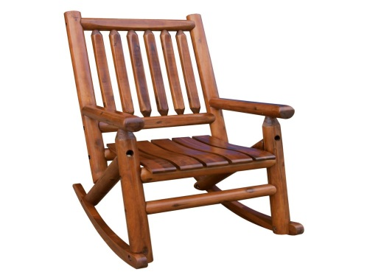](http://www.google.co.nz/url?sa=i&rct=j&q=&esrc=s&source=images&cd=&cad=rja&uact=8&ved=0ahUKEwirkuGu19DWAhXJi7wKHa81A9gQjRwIBw&url=http://www.homedepot.com/p/Leigh-Country-Amberlog-Patio-Rocking-Chair-TX-36000/300518940&psig=AOvVaw0dAnihS09uGljrd1vaUNQi&ust=1506990530069907)